**FROM 2005 and 2015**

**The Small Business Administration’s counseling programs helped to create 149,719 jobs**

The Small Business Administration (SBA) provides counseling and training through its Small Business Development Centers (SBDC) and Service Corps of Retired Executives (SCORE). 3.3 million businesses visited SBA centers at least once during the decade beginning in 2005, and 360,000 businesses visited multiple times. The SBA recorded the number of people employed at businesses when they visited the centers. The map below shows an analysis of the aggregate change in employment related the 360,000 businesses who visited over multiple years.

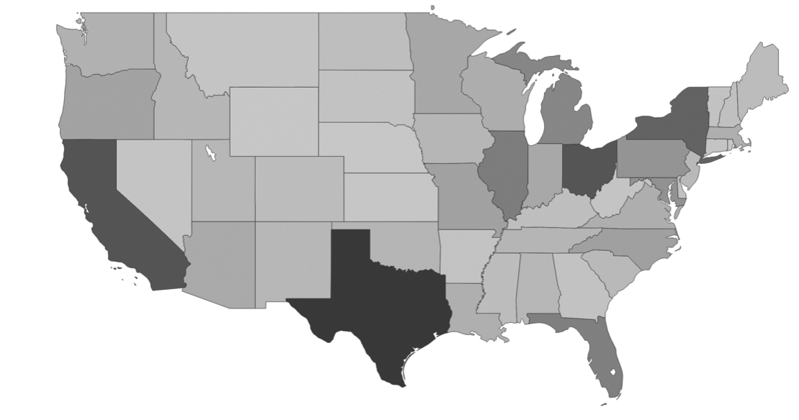

**Need Sub Headline Here**

Based on data reported to USAspending.gov, the SBA spent $918 million to support these counseling and training programs over the decade, which equates to one job per $7,420. The map below shows the average amount of spending per state for every 1 job created by businesses.

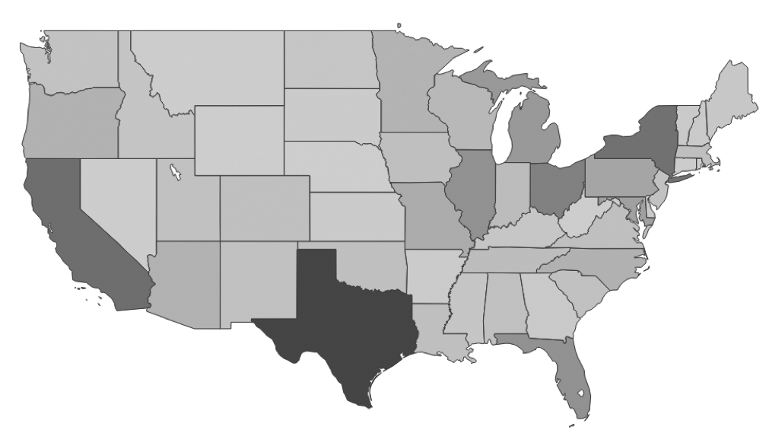

**Top 10 States …** [charts below are placeholder]

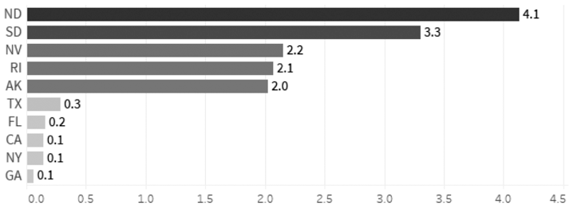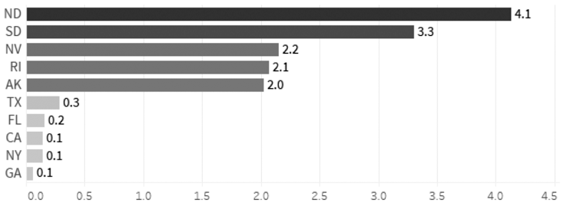

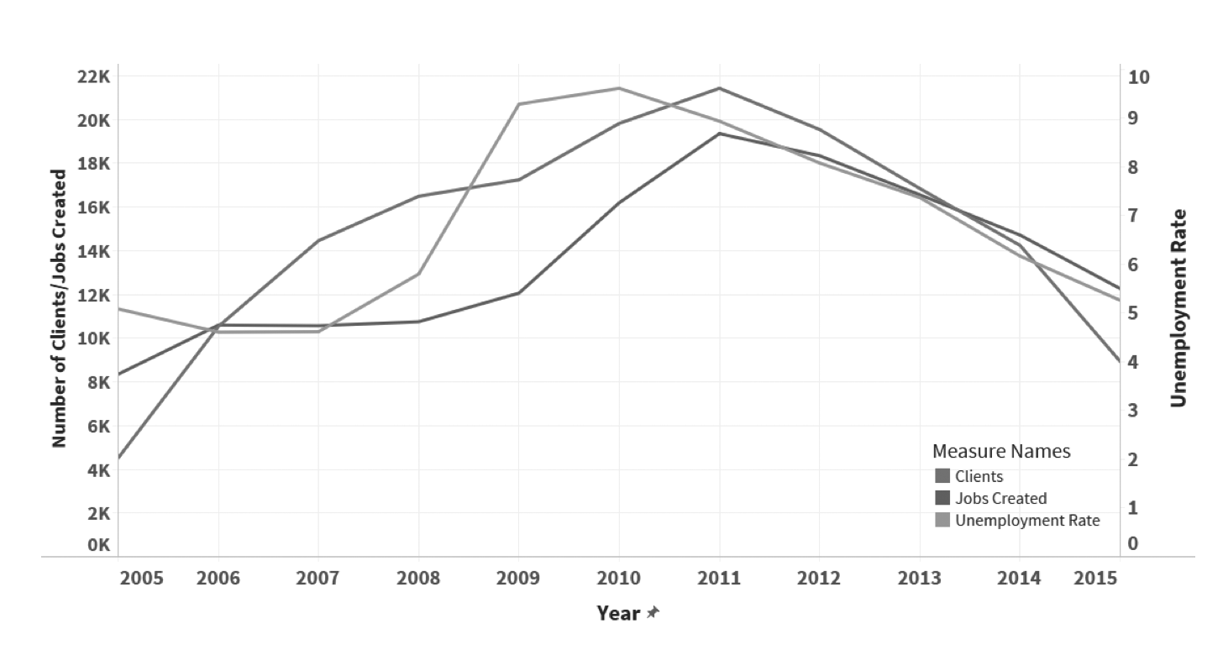

**Need Sub Headline Here**

Given the drastic changes in the national employment picture in the decade following 2005, the analysis below shows how the number of businesses visiting SBA centers and jobs created by those firms changed over time. As the overall employment rate decreased from 2007 to 2010, the number of businesses visiting SBA centers increased, as did the number of jobs created by firms who visited multiple times. From 2010 to 2015, as the employment rate increased, the number of businesses visiting SBA centers decreased, along with the reported jobs created by firms.

**How was this analysis conducted?**

Howie to write, ipsum dolor sit amet, consectetur adipiscing elit. Integer nec odio. Praesent libero. Sed cursus ante dapibus diam. Sed nisi. Nulla quis sem at nibh elementum imperdiet. Duis sagittis ipsum. Praesent mauris. Fusce nec tellus sed augue semper porta.

**Analytics Resources:**

Agency landing page [link]

CFDA page [link]

SBA.gov [link]

**Have Feedback?** [link]